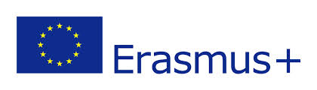
Tytuvėnai regional park

05/05/2016-18/12/2016

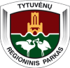
Tytuvėnai regional park was founded in 1992 in order to preserve the picturesque landscape of hills, marshes and lakes, the historical and urban monuments of Šiluva and Tytuvėnai, as well as the unique nature and cultural heritage. The territory of regional park is spread out at the intersection of Kelmė, Raseiniai and Radviliškis districts.
The main aims of Directorate of Tytuvėnai regional park are:
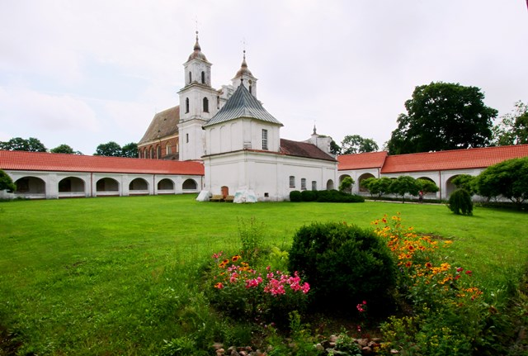
To preserve the unique landscape, preserve and protect local flora and fauna;
To protect and propagate the cultural heritage of the area;
To preserve and restore natural and cultural monuments;
To implement various monitoring and research programmes, collect various information;
To help local people and travellers to know the territory better and to promote eco-friendly tourism;
To organize cultural and educational activities, events, to keep the local community aware about their land and its specifics.
Our target groups: 1) local communities and 2) tourists.

motivation and evs experience:
Our organisation has no previous experience with EVS, so this will be a challenge for all of us. Directorate’s staff will get an opportunity to improve their communication and language skills, to interact with people from different culture, to know more about other countries.
Volunteers will get new experience and will be able to improve their skills. They’ll learn about Lithuanian culture, our cultural heritage and nature, they’ll interact not only with our staff but also with other local people. They’ll have a chance to be ambassadors of their country in our area and spread the word about their culture and values. We’re also hoping that they’ll do the same for us when they’ll come back home: that they’ll tell to others about Tytuvenai regional park and Lithuania.

Project environment:
Directorate of Tytuvėnai regional park is located in a small town that has the same name – Tytuvėnai. The population in this town is about 2400, nearest bigger town is Kelme (our municipality center) with 10 000 people. The nearest city is in about 45 km., it is Šiauliai with population of ~100 000 inhabitants.
Volunteers will work in directorate of Tytuvėnai regional park (where we also have visitor center, exhibition about park and conference hall), there are all conditions to create an individual workspace there, they‘ll also be able to do some activities outside the main place: together with our specialists or on their own.
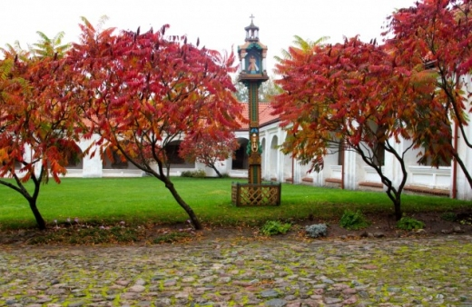
Tytuvėnai and its surroundings is considered to be a good place for vacation: we have two lakes in the town itself and more of them in our territory, most of them are suitable for tourism; town is surrounded by forests. Not so far away from Tytuvėnai (in about 10 km.) flows river Dubysa.
On the other hand, there are not many young people in Tytuvėnai and we have no active night-life. Life gets more active in summer. There are also some bigger and smaller shops, so food, pharmaceuticals and other main necessities are easy to find. We also have local dispensary (not hospital), post and police offices, school, library, christian church. It is possible to reach other locations using bus services.
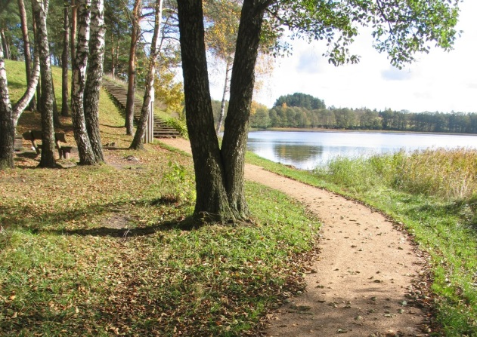
It is very important to understand the specifics of a small town: there is no place in Tytuvėnai where a person can go to spend an evening (like pub or club), it is very quiet here. If a volunteer will have a wish to visit such places, he‘ll have to go to Kelme or Šiauliai. Of course, it is possible to organize your own activities, but a volunteer has to have on his mind that most of the people living in Tytuvėnai are elderly or families with school-age kids (age cap is 18-19 years). Most of the time being here will be calm. It is good for people who like to think, read, have such hobbies as jogging, nature photography or more unusual hobbies that does not require specific places or people (e.g. like fire spinning or anything that comes in mind of potential volunteer who thinks about what he could do on his own in such place).
Volunteers will live in Tytuvėnai. Town is not big and all corners are reachable by foot.

Proposed activities for EVS volunteers:
Volunteer will be introduced with activities hat are being carried in directorate. That includes a wide range of activities:
nature (various monitorings of plants birds, landscape; specific tasks like research of water quality etc... these activities are made depending on need and not every day, but – depending on its nature – at least once a year);
culture (cultural heritage like fortress hills, burial mounds; churches and chapels; communication with older people, gathering stories and legends, songs etc....);
community (collaboration with local communities, schools, municipality and other institutions; mutual events, eco-education etc....);
tourism (work with tourist groups, guided tours, provision of infirmation etc....);
projects (now we’re working on an international Lithuania-Latvia project “Lakes for future”, we’re going to participate in various local and international projects in future too);
other activities (communication with other national and regional parks; preparations of various brochures for publishing, physical work (maintaining the park territory, our visitor center etc....)
Almost all activities are seasonal, that means that a volunteer will do more tourism-related activities on tourism season (May-September), school-related activites on learning season (September-June) and so on.
A volunteer will be threated as an equal team member, he’ll have specific tasks and assignments. Depending on situation, volunteer can be an assistant or organizer, executor or idea generator. Most likely he’ll have to guide tours for tourist groups, help to maintain various areas of park territory, work with park visitors, help with translation (e.g. our web site or booklets)
If volunteers will have a wish to learn some specific lithuanian thing (cooking/songs/dances etc.), we’ll do our best to help them.

Volunteer profiles and recruitment process:
Volunteers who would like to come to us should:
Show interest in nature and cultural heritage;
Be able to work in a small team and independently;
Be willing to do physical work as well as office work; indoors and outdoors;
Be willing to work with tourists and groups of children;
Be creative and fulfill their tasks;
Be open-minded and be able to communicate with new people;
Be able to speak basic english or russian (german language is also possible).

Risk prevention, protection and safety:
The volunteer will not be handling any potentially dangerous equipment or working in an unsafe environment. He/she will be under supervision. Regarding the living and working conditions, the volunteer will be instructed about the general personal safety precautions immediately after arriving in the country and later during the on-arrival training. During this training possible crisis situations and ways to solve them will be analyzed interactively. To be more specific, certain areas can be considered as more risky than others. For example, many tasks of the volunteers will be carried out outdoors, thus one should be ready for minor physical injuries, bodily reactions to nature (plants, insects, animals). Volunteers will be instructed to take precaution wherever and whenever necessary. The experience local staff will be of assistance most of the time.
Another area is the social one. While hoping for the best, one can never know if the complicated cultural/social integration of foreigners will go as smoothly as planned. All people are different, often driven by various emotions, and not always compatible with one another. Special attention to this topic will be given during the training cycle of EVS, but it will also be the task of mentors to guide the young people through this. Mentors will be those people who will be able to tell if volunteers need extra help and what can be done from the side of other EVS and the staff to make things work out in the best possible way.
As mentioned during regular meetings with the mentors volunteers will have time and space to reflect on their EVS lives in different aspects.

Allowance/food money
Monthly food allowance of 110 Euro will be provided.
Monthly allowance (pocket money) of 80 Euro will be provided.
If necessary, transport expenses from the accommodation to work and back will be covered directly to the volunteer upon presenting of travel tickets/receipts. Alternatively a monthly bus ticket or bicycle can be provided. This also applies to travel expenses incurred in attending official EVS trainings or meetings.
International travel expenses to the volunteer will be reimbursed upon presenting travel related financial documents (tickets, invoices, boarding passes, receipts, and other proof of payment) and in line with the travel budget foreseen in the project application are presented to the coordinating organization.

Accommodation:
The volunteer will live in a flat or house in a private room with shared cooking and washing facilities.
In cases, when there is no possibility to rent a flat (no flats available for rent, the rent exceeds the budget etc), the coordinating organization commits itself to accommodate the volunteer in a dormitory in a private room with all necessary living conditions and of adequate standards.
Coordinating organization commits that in the accommodation place volunteer will be provided:
With Internet, with his own bed, a writing table and a seat, a wardrobe, also with all necessary kitchen tools (plates, table tools, pots, pan, pallet, ladle, glasses, cups etc. ) and with necessary domestic appliances (fridge, cooker, washing machine).

About Lithuania
Lithuania is a green and flat land in the north of Europe, ashore the Baltic Sea. It is one of three Baltic countries, and shares borders with Latvia, Byelorussia, Poland and Russia (Kaliningrad). The country is full of preserved natural landscapes, woods, lakes and rivers, and has an unique sea side, with Curonian split, a sandy peninsula, isolating the Curonian sea from the Baltic sea.
Though Lithuania was mentioned already in 1009, now it is a young republic, trying to recover from a grinding occupation of Soviet Union. The independence was retrieved only in 1990, but the history of Lithuanian statehood started already in XIII century, when Mindaugas, the first and only kind of our country, gained the crown. The history of Lithuania is erratic, full of mighty victories and severe events. Today’s Lithuania is a small country, but in historical maps you can find it the biggest country in the Europe, or not existing at all. Today the country, still under impact of 50 years soviet occupation, tries to blend into the economic and cultural space of Europe Union.
As one of the countries in Europe, baptized at the latest, Lithuania preserved much of pagan traditions, and folk traditions are still alive in villages. The cultural life prospers in all the bigger cities.
Area: 650 200 sq. km.
Population: 3 390 000 (year 2006)
Coat of arms and flag:
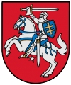 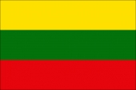

Language:
Official language– Lithuanian, which is the member of Baltic language group (other 2 members are Latvian, and dead Prussian language). It is the most archaic language from all the Indo-European languages.
Religion:
Lithuania is considered to be very religious country, sometimes named as "The land of Virgin Mary". Today 79 percent of Lithuanians consider themselves as Roman Catholics.
Currency:
The currency of Lithuania Republic is Lithuanian Litas (1 Euro = 3,45 Lt). In the year 2009 Euro should be introduced in Lithuania.
Political system:
Lithuanian Republic is the parliamentary democracy. The head of state is The President. Executive authority is Prime minister and the cabinet, and the legislative power is in the hands of Seimas (the parliament)
Neighbors
Latvia (land border – 588 km, sea border – 22 km)
Byelorussia (border – 677 km)
Poland (border – 104 km)
Russia (Kaliningrad) (land border – 255 km, border in Curonian sea – 18 km, sea border– 22 km)
Seaside:
Whole shore is 90 km long. The most unique part of seaside is the Curonian split – the peninsula, which starts in Kaliningrad and creates the Curonian sea.
About Lithuania

Lithuania is a green and flat land in the north of Europe, ashore the Baltic Sea. It is one of three Baltic countries, and shares borders with Latvia, Byelorussia, Poland and Russia (Kaliningrad). The country is full of preserved natural landscapes, woods, lakes and rivers, and has an unique sea side, with Curonian split, a sandy peninsula, isolating the Curonian sea from the Baltic sea.

Though Lithuania was mentioned already in 1009, now it is a young republic, trying to recover from a grinding occupation of Soviet Union. The independence was retrieved only in 1990, but the history of Lithuanian statehood started already in XIII century, when Mindaugas, the first and only kind of our country, gained the crown. The history of Lithuania is erratic, full of mighty victories and severe events. Today’s Lithuania is a small country, but in historical maps you can find it the biggest country in the Europe, or not existing at all. Today the country, still under impact of 50 years soviet occupation, tries to blend into the economic and cultural space of Europe Union.

As one of the countries in Europe, baptized at the latest, Lithuania preserved much of pagan traditions, and folk traditions are still alive in villages. The cultural life prospers in all the bigger cities.

